MEDICAL CLEARANCE TO COMPETE

This form is designed to determine after the initial assessment if an injured competitor is fit to resume competition. It is to be completed by only by a registered medical practitioner. The Clerk of the Course will continue to hold the competition licence if competitor is unfit to resume competition otherwise licence will be returned upon presentation of this signed form which needs to be forwarded immediately to MotorSport New Zealand

1. Details of Injured Person |  |  | 2. Details of Practitioner
Date: |  |  | Name:
Name of competitor: |  |  | MCNZ Number:
Licence No: |  |  | Job title: ie: sport medicine specialist, orthopedic specialist
Address:
 |  |  | Examination location: ie: address of hospital, private practice
3. Non Accident Stand Down
This form is designed to determine after the initial assessment if an injured competitor is fit to resume competition.
If the competitor has been stood down for a reason other than an injury accident the competitor should contact the MSNZ office directly for advice on what is required for a medical clearance to compete.

4. Note to Practitioner
Dear Practitioner
- The motor sport competitor listed above has been stood down from further motor sport competition as the result of a competition accident
- The competitor should have a copy of the initial examination form (On site medical assessment form) which describes the circumstances of the accident and injuries sustained so please take note of the details listed on it
- You are requested to examine the competitor and arrange appropriate radiological and/ or other investigations or specialist assessments as required to determine whether these injuries have been resolved and to determine the competitor’s fitness to return to competition

5. Prior to Assessment
Before examining the competitor, please read the notes below –
- This form can ONLY be completed by a registered medical practitioner
- If the motor sport event medical officer is a registered medical practitioner then that medical officer may complete the required examination and sign this form
- The competitor must have their copy of the ‘On site medical assessment’ form which identifies the initial injury / injuries as well as this blank form with them at the time of examination
- The examining practitioner must fully examine the competitor, complete and sign this form
- The level of medical fitness required for motor sport is at least equivalent to the NZTA requirements for class 2 and above licenses
- All costs involved in this examination are at the competitor’s expense

6. Examination Guidelines for Practitioner to Consider
The competitor should be considered fit to compete under the following circumstances:

- Head injury
- Minor without LOC – after a 3 hour stand down and after medical assessment
- Minor with LOC - after 24 hours and after medical assessment
For the following, the competitor must pass a full neurological assessment and occupational therapy driving assessment
- Moderate head injury (GCS 9-12)
- Major Head injury ( GCS <9, fracture of skull, intracerebral hemorrhage, dural tear, or greater than
24 hours post trauma amnesia)
- Neck & Back injury
- on exclusion of major trauma (medical assessment +/- radiology) and
- once competitor has regained function in spine sufficient for competitive driving.
- Chest and Abdominal injury
- on exclusion of major trauma (medical assessment +/- radiology) and
- once competitor has regained function sufficient for competitive driving
- Limb injury
- on exclusion of major trauma (medical assessment +/- radiology) and
- once competitor has regained sufficient function for competition car control
- Eye injury
- once vision has returned to better than 6/9 (with correction) in the affected eye
- with field of view over 140d and normal stereoscopic vision.
- Other injury as appropriate

7. Diagram of Injuries
If injuries still exist, use the diagram to show full extent of ongoing injuries using codes in box below:
A | Abrasion | H | Haemorrhage
B | Burns | I | IV site
C | Contusion | L | Laceration
D | Dislocation | P | Pain
F | Fracture | S | Swelling

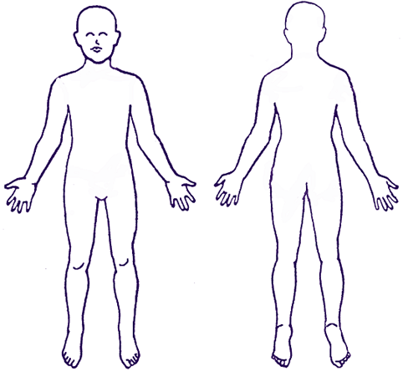

8. Initial Injury Sustained
Give a brief outline/ summary on the medical condition for which the competitor was stood down from competition:
9. If Not Fit to Continue Competition
If competitor is still not considered fit for competition –
Give a brief outline/ summary of reason why competitor is still considered unfit:
Advise of approximate date for review of injuries:
10. SUMMARY and DECLARATION
Examining practitioner: is the competitor fit to resume competition? Yes / No

If yes, the competitor may collect their competition licence from the relevant Clerk of the Course or the MotorSport NZ Office (as applicable) upon presentation of this signed form and resume competition immediately
*I hereby declare that the above information is true and correct*

Signed: ……………………………………………………………….. Signed: …………………………………………………………
Registered medical practitioner Competitor

Name: …………………………………………………………………… Name: ……………………………………………………………

* In all cases the MotorSport New Zealand Medical Assessor has the final determination over a competitor’s fitness to compete *

