AM001A– Accident Report- Multiple Vehicle Accident
- Event and Accident Details
Organising Club: |  |  |  |  |  |  |  |  |  |  |  | Permit #:
- Person Details
Name
Address
Contact No |  |  |  |  |  |  |  |  |  | Date of Birth
Competition Licence Details: |  |  |  |  |  | Licence Grade
Licence Number |  |  |  |  |  |  |  |  |  | Expiry Date
Treated at/by:
Injuries  Nil / Minor / Moderate / Serious / Fatal |  |  |  |  |  |  |  | Where were they injured?  Head / Arms / Torso / Back / Leg / Feet
Stood down from Competition:
Yes / No / For rest of event only
- Vehicle Details
Make / Model
Class
Competition Number
Damage Severity  Nil / Minor / Moderate / Extensive / Fire |  |  |  |  |  |  | Removed to  Pits / Impounded / Other:
Damage Location
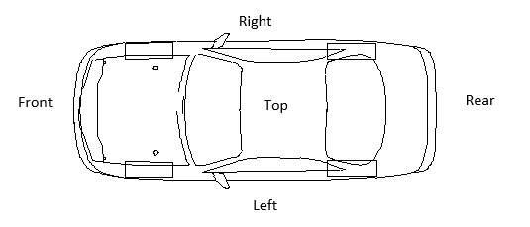
- Safety Features of the Vehicle/Driver
Was Helmet worn: |  |  |  |  |  |  | Y / N
Were Head/Neck Restraints worn: |  |  |  |  |  |  | Y / N Type: HANS / Simpson / Other:
Was the vehicle fitted with a Roll Cage: |  |  |  |  |  |  | Y / N Full Cage / Half Cage
Seats Type (Circle One) |  |  |  |  | Production Seat Competition Seat Seat Head Restraints
If Competition Seats- Type:
Safety Belts - Type: |  |  |  |  |  |  |  |  | Expiry: |  |  |  |  |  | Points: |  |  | 3 / 4 / 5 / 6
Comments on Safety Features:

Number of photos taken/attached __________

