MotorSport New Zealand Inc
Motorsport House
69 Hutt Road
Thorndon, Wellington 6035
P O Box 3793
Wellington 6140
Phone: +64-4-815-8015
Fax: +64-4-472-9011
Email: admin@motorsport.org.nz
Website: www.motorsport.org.nz

ROLL PROTECTION HOMOLOGATION APPLICATION

NOTE: Payment must accompany this application. DO NOT SEND CASH VIA POST (GST Inc)

Standard Processing (First 6 vehicles): $900.00 | Additional vehicles $75.00 each

Applicant:

WHEN PAYING BY CREDIT CARD: Please debit my VISA / MASTERCARD
Card No |  |  |  |  |  |  |  | - |  |  |  |  | - |  |  |  |  |  | - |  |  |  |  |  | Expires
Name of Card Holder
Signed |  |  |  |  |  |  |  |  |  |  |  |  |  |  |  |  |  | Date

Submit completed application with the first 6 (min) vehicle logbook application forms

SECTION TWO: A CLEAR and ACCURATE line drawing must be provided.

SECTION THREE: The applicant MUST IDENTIFY which design prescriptions the roll protection has been constructed to.

SECTION FOUR: Detail ALL members of the rollbar/rollcage and reference each member on drawing in Section Two. The material description, material standard, and the material specifications must be provided.

SECTION FIVE: Measurements must be provided for the main rollbar and front/lateral rollbar bends reduction (A) and expansion (B) accurate to the nearest 0.1mm. Measurement X is the original outside tube diameter (OD), which must be measured away from the bend.

SECTION SIX: Identify the welding method used, the wire/electrode type and size, the welding technicians’ name, qualifications, and company.

- SECTION SEVEN: Provide the actual measurements of the safety cage as viewed through the door opening. The minimum/maximum dimensions are detailed in the chart. Additionally, confirm that in frontal projection, any reinforcement of bends and junctions of the upper corners of the front rollcage are contained within the shaded area of the drawing.

- SECTION EIGHT: Details of the material, thickness and area of the Reinforcement Plate must be supplied. If rollbar leg Footings or Footing Boxes are incorporated in the design, full details of these are also required. When the roll protection is removable, (ie. when the rollbar footing plates are bolted to the reinforcement plates that are welded to the vehicle structure), full details of these fasteners are required in Section Nine.

- SECTION NINE: Only demountable joints as authorised by FIA Appendix J or Schedule A are acceptable. Please note the restricted use of some joint types (e.g. hinge type, directional load type etc). All joint types, fasteners and locking methods must be detailed.

- SECTION TEN: Approval of an existing (un-homologated) structure is only possible under Schedule A (for National competitions). Contact the MotorSport NZ office to organise an inspection by a Technical Officer or Technical Advisor where appropriate.

SECTION ELEVEN: Declaration 1 – Required to be completed by the manufacturer of the roll protection and sign accordingly to confirm that the safety structure has been designed, constructed and installed in compliance with the applicable regulations.

Declaration 2 – is required where the material is purchased as a ‘Appendix J Kit-Set’ hence MUST be installed by a MotorSport NZ recognised installer (who shall complete the declaration accordingly).

Declaration 3 – shall be completed by the NZ supplier of the ‘Appendix J Kit-Set’.

SECTION TWELVE: All applicable photographs MUST be supplied of the UN-PAINTED structure and MUST be CLEAR and CLOSE-UP views. NOTE: Quality digital photos are accepted either burned to a CD or e-mailed to technical@motorsport.org.nz

FOR SCHEDULE A DESIGN COMPLIANCE ONLY

These drawings may be used as the basis of your line drawing for SECTION TWO
Accurately and clearly draw-in all the rollbar / rollcage members incorporated in the design

MotorSport NZ Inc
PO Box 133, Paraparaumu 5032
102a Kapiti Road, Paraparaumu 5254
+64 4 815 8015
www.motorsport.org.nz

technical@motorsport.org.nz

Homologation Number and Approval Date:

NZTA _ _ _ _/_ _/_ _ _

Approval Date:

FIA Homologation #

MSNZ Logbook:

FOR OFFICE USE ONLY

Representing the

ROLL PROTECTION

TYPE APPROVAL HOMOLOGATION APPLICATION

Not Valid for INTERNATIONAL COMPETITIONS

Application Date: _ _ / _ _ / _ _ _ _ Application Prepared by: _ _ _ _ _ _ _ _ _ _ _ _ _ _ _ _ _ _ _ _ _ _

SECTION ONE – VEHICLE / OWNER DETAILS
Manufacturer: _ _ _ _ _ _ _ _ _ _ _ _ _ _ _ _ _ Model: _ _ _ _ _ _ _ _ _ _ _ _ _ _ _ _ _ Yr of Manufacture: _ _ _ _ _ _ _ _
Registration No: _ _ _ _ _ _ _ _ _ _ _ _ _ Vehicle Chassis #: _ _ _ _ _ _ _ _ _ _ _ _ _ _ _ _ _ _ _ _ _ _ _ _ _ _ _ _ _ _ _ _ _
Owner: _ _ _ _ _ _ _ _ _ _ _ _ _ _ _ _ Postal Address: _ _ _ _ _ _ _ _ _ _ _ _ _ _ _ _ _ _ _ _ _ _ Phone: _ _ _ _ _ _ _ _ _ _ _

SECTION TWO – ROLLBAR / ROLLCAGE DRAWING (line drawing of actual structure)
Drawing to be accurate representation of actual structure installed in vehicle clearly detailing ALL members. Number each member
(Ref. Section Four)

SECTION THREE – ROLL PROTECTION DESIGN COMPLIANCE
The rollbar / rollcage as described herein has been designed, fabricated and installed in the vehicle detailed above in accordance with the specified requirements of (tick box as appropriate);
NATIONAL COMPETITONS: MotorSport NZ - Appendix Two, Schedule A - Article 4.4.
INTERNATIONAL COMPETITONS: FIA Appendix J

SECTION FOUR – MATERIAL SPECIFICATION
NOTE: Member numbers to reference SECTION TWO drawing
Member number | Member name | Material  Description / Standard | Outside Diameter  (mm) | Wall Thickness  (mm) | Tensile Strength (MPa)
1. | Main Hoop
2. | Backstays
3. | Diagonals
4. | Lateral / Front rollbar
5. | Safety Harness Bars
6. | Other (specify)
7.
8.
9.
10.
11.
12.
13.
14.
15.
16.

SECTION FIVE – MATERIAL BEND MEASUREMENTS
 | Main Rollbar | Lateral Rollbar
Original Size: | X = mm | X = mm
Reduction: | A = mm | A = mm
Expansion: | B = mm | B = mm
Calculation: | A ÷ B = | A ÷ B =

SECTION SIX –WELDING DETAILS
Primary Welding Method: | MIG | TIG
Wire Type & Size:
Welding Technicians’ Name:
Company:
Technicians’ Qualifications:
 | All joins fully welded through 360° (Tick box)

SECTION SEVEN – POSITION OF MEMBERS IN DOOR / WINDSCREEN APERTURES
Door aperture - complete as applicable to design
A = 300mm MIN | Actual = mm
B = 250mm MAX | Actual = mm
C = 300mm MAX | Actual = mm
E = ( Less than ½ H) | Actual = mm
H = (Height of Door) | Actual = mm
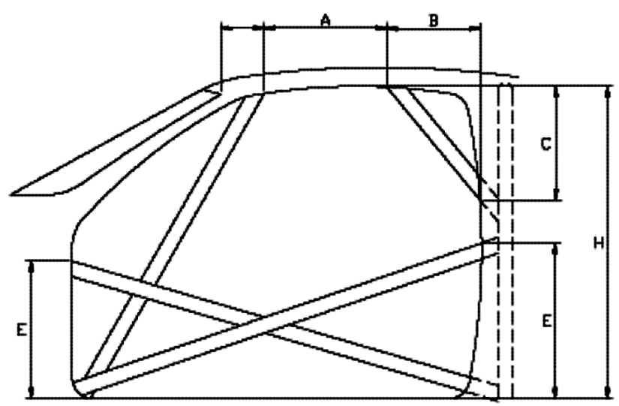

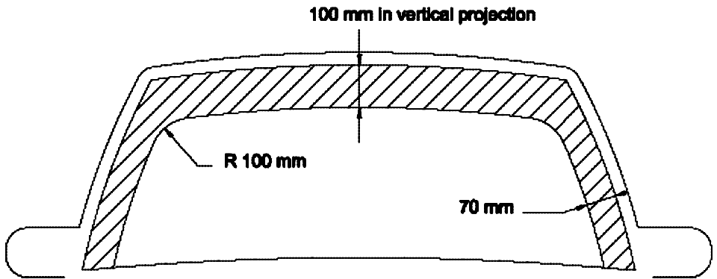

Confirmed that any reinforcement members are contained within shaded area (Tick box)

SECTION EIGHT – ATTACHMENT TO BODYSHELL / CHASSIS
 | Main rollbar | Lateral / Front rollbar | Backstays
Reinforcement Plate  (being plate welded to bodyshell) | Material:  Thickness: mm  Area: cm² | Material:  Thickness: mm  Area: cm² | Material:  Thickness: mm  Area: cm²
Footing Box  (being the box welded to reinforcement plate) | Material:  Thickness: mm  Area: cm² | Material:  Thickness: mm  Area: cm² | Material:  Thickness: mm  Area: cm²

SECTION NINE – REMOVABLE MEMBERS / FASTENERS

 | None Fitted (Tick box where applicable)
Tick boxes as appropriate | Removable members fitted (as follows): |  | Joint Drawing No.  (from MotorSport Manual) | Photograph No.  (from Section Eleven)
 |  | Backstays to main rollbar
 |  | Lateral rollbar to main rollbar
 |  | Connecting members
 |  | Diagonal members
 |  | Side intrusion members
 |  | Other (specify)

Member | Fastener Type | Number Fitted | Size | Grade | Locking Method

SECTION TEN – INSPECTION BY TECHNICAL OFFICER (ONLY COMPLETE IF DIRECTED)
Section Ten is ONLY applicable to Schedule A homologation applications for roll protection structures not previously homologated by MotorSport NZ, where the manufacturer is unknown and/or construction data is unavailable to complete the application in full. Please note that this inspection report is not a guarantee of homologation acceptance.
To be completed by Technical Officer / Technical Advisor only
I have inspected the structure fitted to the vehicle detailed in Section One of this application and confirm that:
- The construction / design is in compliance with the specifications of Schedule A; and
- The structure has been professionally constructed and is in an acceptable condition; and
- The structure design does not impede the operation of any mandatory controls; and
- The structure design does not unreasonably hinder the entry and/or exit of the vehicle; and
- Clear, close-up pictures of the specified areas of the UN-PAINTED structure are provided; and
- (if fitted) any demountable joints / fasteners are correctly located and of an approved type and strength.
Safety Cages previously homologated by an overseas ASN (with accompanying ASN documentation)

I have inspected the safety cage and the documentation provided relative to the vehicle detailed in Section One of this application and confirm that:
- The construction / design is as per the documentation and the structure is in an acceptable condition
In addition, I make the following comments:

Name: Signature: Licence #:

SECTION ELEVEN – DECLARATIONS
Choose either DECLARATION 1 or DECLARATIONS 2 & 3 and complete in full.
1 - DECLARATION BY MANUFACTURER
For all applications EXCEPT ‘Appendix J Kit-Set’ safety cages
Company Name: _ _ _ _ _ _ _ _ _ _ _ _ _ _ _ _ _ _ _ _ _ _ _ _ _ _ _ _ _ _ _ Phone No.: _ _ _ _ _ _ _ _ _ _ _ _ _ _ _ _
E-mail: _ _ _ _ _ _ _ _ _ _ _ _ _ _ _ _ _ _ _ _ _ _ Physical Address: _ _ _ _ _ _ _ _ _ _ _ _ _ _ _ _ _ _ _ _ _ _ _ _ _ _
_ _ _ _ _ _ _ _ _ _ _ _ _ _ _ _ _ _ _ _ _ _ _ _ _ _ _ _ _ _ _ _ _ _ _ _ _ _ _ _ _ _ _ _ _ _ _ _ _ _ _ _ _ _ _ _ _ _ _ _ _ _
I hereby declare that the rollbar/rollcage, as detailed in this application, has been manufactured and installed in total conformity with the specified requirements of Schedule A – Article 4.4 / FIA Appendix J (delete as applicable).

Name: _ _ _ _ _ _ _ _ _ _ _ _ _ _ _ _ _ _ _ _ _ _ _ _ _ _ _ _ _ Position in Company: _ _ _ _ _ _ _ _ _ _ _ _ _ _ _ _ _ _
Signature: _ _ _ _ _ _ _ _ _ _ _ _ _ _ _ _ Qualifications: _ _ _ _ _ _ _ _ _ _ __ _ _ _ _ _ _ _ _ _ _ _ _ _ _ _ _ _ _

2 - DECLARATION BY RECOGNISED APPENDIX J COMPLIANT KIT-SET SAFETY CAGE INSTALLER
Only applicable where the structure has been purchased as a ‘Appendix J Kit-Set’
I the undersigned, hereby declare that the kit-set safety cage as supplied by the company detailed below has been installed in accordance with the exacting requirements of the installation instructions supplied with the kit-set and the requirements of Schedule A and/or Appendix J Article 253-8.4.

Installers Company Name: _ _ _ _ _ _ _ _ _ _ _ _ _ _ _ _ _ _ _ _ _ _ _ _ E-mail: _ _ _ _ _ _ _ _ _ _ _ _ _ _ _ _ _ _ _ _
Physical Address: _ _ _ _ _ _ _ _ _ _ _ _ _ _ _ _ _ _ _ _ _ _ _ _ _ _ _ _ _ _ _ _ _ _ _ _ _ _ _ _ _ _ _ _ _ _ _ _ _ _ _ _ _

Name: _ _ _ _ _ _ _ _ _ _ _ _ _ _ _ _ _ _ __ _ _ _ _ _ _ Position in Company: _ _ _ _ _ _ _ _ _ _ _ _ _ _ _ _ _ _ _ _ _
Signature: _ _ _ _ _ _ _ _ _ _ _ _ _ _ _ Qualifications: _ _ _ _ _ _ _ _ _ _ _ _ _ _ _ _ _ _ _ _ _ _ _ _ _ _ _ _ _ _
Welding Technicians’ Name and Qualifications: _ _ _ _ _ _ _ _ _ _ _ _ _ _ _ _ _ _ _ _ _ _ _ _ _ _ _ _

2.1 - DECLARATION BY NZ SUPPLIER OF APPENDIX J KIT-SET SAFETY CAGE
Suppliers’ Company Name: _ _ _ _ _ _ _ _ _ _ _ _ _ _ _ _ _ _ _ _ _ _ _ _ _ _ _ Phone No.: _ _ _ _ _ _ _ _ _ _ _ _ _ _ _
I the undersigned declare that this ‘kit-set’ safety cage as manufactured by _ _ _ _ _ _ _ _ _ _ _ _ _ _ _ _ _ _ _ _ _ _ _ _
has been sold on the understanding that it will be installed by a MotorSport NZ recognised installer.
Name: _ _ _ _ _ _ _ _ _ _ _ _ _ _ _ _ _ Position in Company: _ _ _ _ _ _ _ _ _ _ _ _ Signature: _ _ _ _ _ _ _ _ _ _ _ _

SECTION TWELVE – PHOTOGRAPHS

MAIN ROLLBAR - TOP BEND DETAIL
MANDATORY PHOTOGRAPH

All photographs of UNPAINTED structure MUST BE CLEAR and CLOSE-UP.

LATERAL / FRONT ROLLBAR - TOP BEND DETAIL
MANDATORY PHOTOGRAPH

All photographs of UNPAINTED structure MUST BE CLEAR and CLOSE-UP.

SECTION TWELVE – PHOTOGRAPHS (continued)

MAIN ROLLBAR LEG - ATTACHMENT DETAIL TO FLOORPAN / CHASSIS
MANDATORY PHOTOGRAPH

All photographs of UNPAINTED structure MUST BE CLEAR and CLOSE-UP.

LATERAL / FRONT ROLLBAR LEG - ATTACHMENT DETAIL TO FLOORPAN / CHASSIS
MANDATORY PHOTOGRAPH

All photographs of UNPAINTED structure MUST BE CLEAR and CLOSE-UP.

SECTION TWELVE – PHOTOGRAPHS (continued)

BACKSTAY - LOWER ATTACHMENT DETAIL TO FLOORPAN / CHASSIS
MANDATORY PHOTOGRAPH

All photographs of UNPAINTED structure MUST BE CLEAR and CLOSE-UP.

‘B’ POST - ATTACHMENT DETAIL
WHERE NO PHOTOGRAPH IS ATTACHED IT WILL BE ACCEPTED THAT
THERE IS NO ‘B’ POST ATTACHMENT

All photographs of UNPAINTED structure MUST BE CLEAR and CLOSE-UP.

SECTION TWELVE – PHOTOGRAPHS (continued)

SAFETY HARNESS - ATTACHMENT DETAIL TO ROLL PROTECTION MEMBER/S
PHOTOGRAPH/S REQUIRED OF ALL HARNESS ATTACHMENT
POINTS TO ROLLBAR / ROLLCAGE MEMBERS

All photographs of UNPAINTED structure MUST BE CLEAR and CLOSE-UP.

SIDE VIEW OF FRONT DOOR OPENING (refer Drawing No. 253-17D)
MANDATORY PHOTOGRAPH FOR
ALL ROLLCAGE DESIGNS

All photographs of UNPAINTED structure MUST BE CLEAR and CLOSE-UP.

SECTION TWELVE – PHOTOGRAPHS (continued)

FRONT VIEW THROUGH WINDSCREEN (refer Drawing No. 253-17E)
MANDATORY PHOTOGRAPH FOR
ALL ROLLCAGE DESIGNS

All photographs of UNPAINTED structure MUST BE CLEAR and CLOSE-UP.

COMPETITION SEAT MOUNTING RAILS (when attached to safety cage)
WHERE NO PHOTOGRAPH IS ATTACHED IT WILL BE ACCEPTED THAT THERE ARE
NO SEAT MOUNTING RAILS ATTACHED TO THE SAFETY CAGE

All photographs of UNPAINTED structure MUST BE CLEAR and CLOSE-UP.

SECTION TWELVE – PHOTOGRAPHS (continued)

REMOVABLE MEMBER – JOINT DETAIL (1)
WHERE NO PHOTOGRAPH IS ATTACHED IT WILL BE ACCEPTED THAT THERE ARE NO
REMOVABLE MEMBERS

All photographs of UNPAINTED structure MUST BE CLEAR and CLOSE-UP.

REMOVABLE MEMBER – JOINT DETAIL (2)
WHERE NO PHOTOGRAPH IS ATTACHED IT WILL
BE ACCEPTED THAT THERE ARE NO
REMOVABLE MEMBERS

All photographs of UNPAINTED structure MUST BE CLEAR and CLOSE-UP.

