SAFETY CAGE / ROLLBAR HOMOLOGATION APPLICATION Technical Form T002

IMPORTANT INFORMATION ABOUT THIS APPLICATION

ALL APPLICANTS MUST READ THIS IMPORTANT IMFORMATION AND MUST FOLLOW THE REQUIREMENTS OF THIS APPLICATION OR IT MAY BE RETURNED AND AN ADDITIONAL 50% OF THE ORIGINAL FEE CHARGED
If you require help / assistance in completing this application please refer to the ‘Guidelines for Safety Cage Homologation’ available on the MSNZ website or phone the Technical Department for assistance.
Once complete forward original documents either by Courier to physical address or Mail to PO Box as above.

MSNZ Vehicle Logbook: A valid logbook or logbook application (Form T001) MUST accompany this application.

Instruction 1 (Section 1): Complete ALL vehicle details and ensure manufacturers’ Chassis No. is correct. Registration No. is only applicable for road registered vehicles.

Instruction 2 (Section 2 & 9): In Section 2 complete Constructor details and in Section 9 the appropriate Declaration MUST be completed and signed. Declaration 1 is solely for MSNZ Recognised Safety Cage Manufacturers. Declaration 2 is for all other individuals constructing Schedule A compliant safety structures. Homologation certification cannot be issued when a false declaration is made hence it is imperative that the signatory is fully conversant with the stated regulations and is suitably qualified to make the declaration.

Instruction 3 (Section 3): A CLEAR and ACCURATE line drawing of the structure must be provided detailing ALL the tube members which MUST be individually numbered and referenced in Section 4.

Instruction 4 (Section 4): All tube members of the structure MUST be detailed here. If multiple members are fitted (e.g. 2x lateral rollbar, reinforcements etc) they only need detailing once provided they have the same number in section 3 drawing. Only tube manufactured to the MSNZ standard – steel tubes for safety cages is authorised (excepting Recognised Manufacturers). Material specifications should be stated as per the material ‘specification sheet’ available from the material supplier.

Instruction 5 (Section 5): Measurements of the main rollbar and front/lateral rollbar top bends; reduction (A) and expansion (B) must be accurate to the nearest 0.1mm. Measurements should be performed at the centre of the bend radius and prior to welding in other members.

Instruction 6 (Section 6): The welding technician MUST be an accomplished trade’s person with trade qualifications and/or proven/trade experience. The welding declaration MUST be ticked to confirm that all joins of the principle structure are welded through 360°.
- Instruction 7 (Section 7): A reinforcement plate welded to the bodyshell is mandatory for each lower attachment point of the main & lateral/front rollbars and the backstays – material and measurements must be provided. The minimum area is that in full contact with the bodyshell / chassis. A footing box may also be incorporated in the design, mounted on top of the reinforcement plate – material and measurements must be provided. In the case of removable structures a footing plate is required welded to the rollbars and in turn bolted to the reinforcement plate and all fastener specifications must be provided.
- Instruction 8 (Section 8): Provide the actual measurements of the safety cage as viewed through the door opening. Confirm that in frontal projection, the front/lateral rollbar and any reinforcement members are contained within the shaded area of the drawing.

Photographs: All applicable photographs MUST be included with this application. All photographs MUST be of the UN-PAINTED structure and MUST be CLEAR and CLOSE-UP views. Hi resolution digital photos are preferable (clearly identifying applicants name and vehicle details) either on CD or by e-mail to technical@motorsport.org.nz

You can submit your application via MotorSport Online! To request log in details for an existing record or to register please go to https://online.motorsport.org.nz/
Please note that manual applications will take longer to process than applications submitted via the online system.
Please make sure your application is complete and all information is provided including any photos. Additional charges may be incurred for incomplete or substandard applications that require extra work or research. (Refer MotorSport Manual Sch B)

PAYMENT BY CREDIT CARD: Please debit my VISA / MASTERCARD (a 2.5% surcharge applies to all credit card payments)
Card No |  |  |  |  |  |  | - |  |  |  |  |  | - |  |  |  |  |  | - |  |  |  |  |  | Expires
Name of Card Holder
Signed |  |  |  |  |  |  |  |  |  |  |  |  |  |  |  |  |  | Date
Standard Processing: $250.00 |  |  |  |  |  |  |  |  |  |  |  | Priority Processing + $125.00 ($375.00 total)
Payments can be made by Internet Banking to: ASB Bank 12-3192-0017344-00
(Please reference Name and Application Type)
GST No. 10-062-349 Payment Details- Fee’s Effective as of 01 Jan 2020

SAFETY CAGE / ROLLBAR CERTIFICATE

In compliance with MotorSport New Zealand Homologation Regulations for Safety Cages
Appendix Two Schedule A – Part One Article 4.6 and Part Two Article 5 of the current MotorSport NZ Manual

This certificate is valid for all National competitions for the structure bearing the above homologation number

[Note: Form T002-FIA must be used to certify safety structures for International Competitions]

SECTION 1- VEHICLE DETAILS (Refer Instruction 1)
Vehicle Make: |  |  |  |  | Vehicle Model: |  |  |  |  |  |  | Year:
Vehicle Chassis No.: |  |  |  |  |  |  |  |  |  |  | Registration No.:

SECTION 2- SAFETY CAGE CONSTRUCTOR DETAILS
Constructor Name:
Postal Address:
Email Address: |  |  |  |  |  |  | Daytime Phone #:

SECTION 3 SAFETY CAGE / ROLLBAR DRAWING (Refer Instruction 3)

SECTION 4- MATERIAL SPECIFICATION (Refer Instruction 4)
Member Number | Member Name | Material  Description / Standard | External Diameter  (mm) | Wall Thickness  (mm) | Tensile Strength (MPa)
Principle structure
1. | Main Rollbar
2. | Lateral / Front Rollbar
3. | Backstays
4. | Diagonals
5. | Windscreen Bar
6. | Safety Harness Bar
Other members (detail ALL other members)
7. | Side Intrusion Bars
8. | Reinforcement Bars
9. | Forward Extension
10.
11.
12.
13.
All tube members declared to be the same material standard as detailed above (√ box) |  |  | Note: Froward extensions required when MOPS/SRS is removed on  road registered vehicle’s

SECTION 5- MATERIAL BEND MEASUREMENTS (Refer Instruction 5)

 | Main Rollbar | Lateral Rollbar
Original Size: | X = mm | X = mm
Reduction: | A = mm | A = mm
Expansion: | B = mm | B = mm
Calculation: | A ÷ B = | A ÷ B =

SECTION 6- WELDING DETAILS (Refer Instruction 6)
Primary Welding Method  And Declaration:  ( Box) | MIG TIG | ALL JOINS WELDED THROUGH 360°
Welding Technicians’ Name:
Technicians’ Qualifications:

SECTION 7- ATTACHMENT TO BODYSHELL / CHASSIS (Refer Instruction 7)
 | Main rollbar | Lateral / Front rollbar | Backstays

Welded structures
Reinforcement Plate  (mandatory plate that is welded to bodyshell) | Material:  Thickness: mm  Area: cm² | Material:  Thickness: mm  Area: cm² | Material:  Thickness: mm  Area: cm²
Footing Box  (being optional fabricated  ‘box’ welded directly to the reinforcement plate) | Material:  Thickness: mm  Area: cm² | Material:  Thickness: mm  Area: cm² | Material:  Thickness: mm  Area: cm²

Removable structures
Footing Plate  (optional plate welded to rollbar and bolted to the reinforcement plate) | Material:  Thickness: mm  Area: cm² | Material:  Thickness: mm  Area: cm² | Material:  Thickness: mm  Area: cm²
Attachment details  (bolts / nuts minimum  grade ISO 8.8) | Bolt size:  Bolt grade:  Locking method: | Bolt size:  Bolt grade:  Locking method: | Bolt size:  Bolt grade:  Locking method:
Note: Any demountable joints to be detailed on separate sheet

SECTION 8- POSITION OF MEMBERS IN WINDSCREEN / DOOR APERTURES (Refer Instruction 8)

Windscreen aperture
Confirmed that any reinforcement members are contained within shaded area (√ box)
Door aperture
A = 300mm MIN | Actual = mm
B = 250mm MAX | Actual = mm
C = 300mm MAX | Actual = mm
E (front) = ( Less than ½ H) | Actual = mm
E (rear) = ( Less than ½ H) | Actual = mm
H = (Height of Door) | Actual = mm
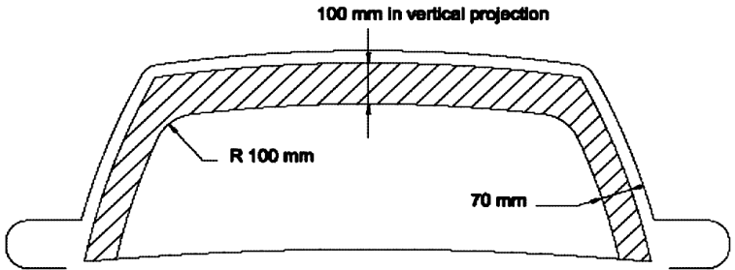

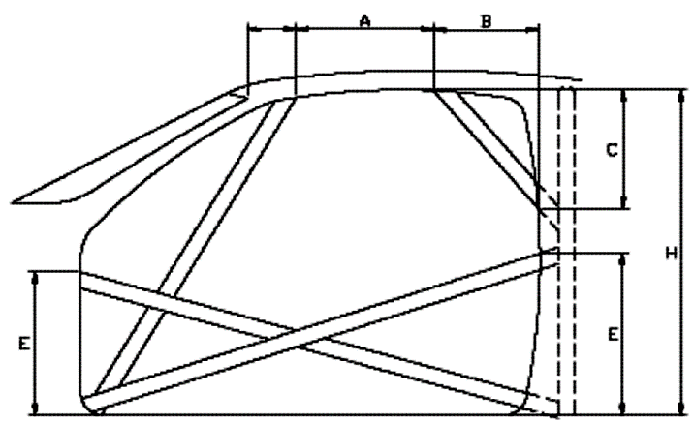

SECTION 9- DECLARATIONS
1 - DECLARATION BY MSNZ RECOGNISED MANUFACTURER
On behalf of the company named below I hereby declare that the structure as detailed in this application has been designed, fabricated and installed in total conformity with the current specified requirements of MSNZ Appendix Two, Schedule A Part One Article 4.6 and Part Two Article 5 or as approved in writing by the MSNZ Technical Department.
Company Name: |  |  |  |  |  |  |  | MSNZ Recognition No.: |  |  |  | RM
Signatory Name: |  |  |  |  |  |  | Position Held:
Signature:
Alternative design / material specification approved through calculation report or demonstrated qualifications
Name of Company / Engineer:
Report No.:
2 - DECLARATION BY CONSTRUCTOR
I hereby declare that I have read and understood the requirements of this certification and that the structure as detailed in this application has been designed, fabricated and installed in total conformity with the current specified requirements of MSNZ Appendix Two, Schedule A Part One Article 4.6 and Part Two Article 5.
Name: |  |  |  |  |  |  |  |  |  | Signature:
Qualification / Experience:
Postal Address:
Email Address: |  |  |  |  |  |  |  |  | Phone #:

INSPECTION REPORT (FOR OFFICIAL USE ONLY)
An inspection report is ONLY required when a physical inspection is requested by the MSNZ Technical Dept
- Safety Cage previously homologated by an overseas ASN
- The construction / design is in compliance with the specifications of Schedule A or FIA Appendix J
- The tube used is identified as meeting the size and strength requirements of Schedule A
- The structure has been professionally constructed and is in an acceptable condition
- The structure design does not unreasonably hinder the entry and/or exit of the vehicle
- Clear, close-up pictures of the specified areas of the structure are provided
- (if fitted) any demountable joints / fasteners are correctly located and of an approved type and strength.
- Other;

Name: _ _ _ _ _ _ _ _ _ _ _ _ _ _ _ _ _ _ _ _ _ _ _ _ _ _ _ _ _ _ _ _ _ _ _ _ _ MSNZ Officials Licence No.: _ _ _ _ _ _ _ _
Signature: _ _ _ _ _ _ _ _ _ _ _ _ _ _ _ _ _ _ _ _ Dated: _ _ _ _ _ _ _ _ Acceptance stamp:

PHOTOGRAPHS

The following photographs must be presented with this application

Refer Note | PICTURE DETAIL REQUIRED | Confirmed photo included
1 | General view showing rearwards members
2 | General view showing forward members
3 | Main rollbar top bend
4 | Lateral / Front rollbar top bend
5 | Main rollbar attachment detail to floorpan
6 | Lateral / Front rollbar attachment detail to floorpan
7 | Backstay attachment detail to floorpan
8 | Safety Harness bar attachment detail to other members
9 | View of complete drivers door opening
10 | View through front windscreen
11 | Forward Extension (if applicable)

All photographs MUST be of the UN-PAINTED structure and MUST be CLEAR therefore in focus to clearly show the detail of the structure.

Hi resolution digital photos are preferable presented on a CD with the application or submitted by e-mail to technical@motorsport.org.nz

CLEARLY MARK CD OR E-MAIL WITH APPLICANTS NAME AND VEHICLE DETAILS.

Printed photographs may also be accepted (9cm x 13cm print size) included with the application
Only send necessary photos as noted below- If additional photos are required they will be requested

Photograph Notes;

General view of rear half of structure taken through door opening

General view of front half of structure taken through door opening

Close-up view of main rollbar top bend detail and member welding

Close-up view of lateral/front rollbar top bend detail and member welding

& 6) Close-up view of rollbar attachment to reinforcement plate

Close-up view of backstay attachment to reinforcement plate

General view of harness bar and its attachment to safety cage structure

View of complete door opening (taken from outside of vehicle - door open wide)

10) Clear view looking into front windscreen (taken standing in front of bonnet in drivers line of sight). Do not use flash!

DRAWINGS

These line drawings may be used as the basis of the drawing

(Do not use for complex designs)
Accurately and clearly draw-in all other tube members of your actual Safety Cage / Rollbar design.

