MotorSport NZ Inc
PO Box 133, Paraparaumu 5032
102a Kapiti Road, Paraparaumu 5254
+64 4 815 8015
www.motorsport.org.nz
licence@motorsport.org.nz

On Site Medical Assessment Form

Initial Assessment of Persons at Accident Scene

This form is designed to record at the initial assessment the extent of the injuries to any person at an event and if an injured competitor is fit to continue competition. It is to be completed by the event medic (paramedic, advanced paramedic, or medical officer) on site when an accident has occurred. If the injured person is non-compliant during medical exam, it must be reported to the clerk of the course.
In cases of emergency, this on site medical assessment form can be completed retrospectively by the appropriate medic
A copy of this form must be given to the injured person and clerk of the course, with a copy forwarded immediately to MotorSport New Zealand
1. Details of Involved Person | 2. Event Details
Involved Person: Competitor / Event Official / Public  Name:  Address:  ……………………………………………………………………………………………  ……………………………………………………………………………………………  Competition licence number:  ^{If applicable}  Car number:  ^{If applicable}  Notes: ………………………………………………………………………………  ……………………………………………………………………………………………  ……………………………………………………………………………………………  ……………………………………………………………………………………………  Was the competitor wearing a head/neck restraint such  as a HANS Device? ……………………………………………………… | Date: …………………………………………………………………………………  Permit Number: ……………………………………….........................  Organising Club: ……………………………………….........................  Event Title: ……………………………………….................................  Please circle:  Race / Rally / ClubSport / Historic/Classic  Accident Locality: …………………………………………………………….  eg. Hairpin / Higgins / Castrol Corner / Pits / Midway between points 6 and 7 / etc  Examination location: ………………………………………................  Examination time: ……………………… am / pm  Name of examining medic: ……………………………………………...  Please circle:  Paramedic / Advanced paramedic / Medical officer /  First Aider / Nurse
3. Involvement in Accident
Has the involved person -

Been involved in an accident causing injury? Y / N

Been involved in a high impact accident? Y / N

Been involved in a roll over accident? Y / N

Been involved in another accident of concern? Y / N

- If the answer to any of the above is YES, complete the rest of the form and ensure that the competitor is in possession of a Medical Clearance to Compete form -
- If the answer to ALL of the above is NO, a competitor is free to return to competition and further examination is not required – please complete declaration (section 8)
RESTRICTED CIRCULATION
This report is for the use of MotorSport New Zealand only. Do not distribute to public persons or bodies or the news media without prior written permission from an authorised MotorSport New Zealand Inc. representative.
4. Examination
A) Head injury  - GCS ................  - Minor head injury with loss of consciousness Y / N  - Minor head injury without loss of consciousness Y / N  - Moderate head injury (GCS 9-12) Y / N  - Major head injury (GCS <9) Y / N  - Fracture of skull, intercerebral haemorrhage, dural  - tear, >24 hours post trauma amnesia  B) Neck injury  - significant pain Y / N  - loss of movement in neck Y / N  C) Back injury  - significant pain Y / N  - loss of movement in back Y / N  D) Chest injury  - significant pain limiting mobility and/or respiration Y / N  - significant chest wall bruising Y / N | E) Abdominal injury  - significant pain and tenderness in abdomen Y / N  F) Limb injury  - fracture or significant limb derangement Y / N  - large haemarthrosis Y / N  - soft tissue injury resulting in loss of function to the  affect limb likely to affect driving Y / N  G) Eye injury  - resulting in reduction in visual acuity  in affected eye below 6/9 Y / N  H) Any other significant injury as  determined by the examining medic Y / N  I) Need for hospital examination? Y / N  If yes, name hospital to be transferred to:  ……………………………………………………………………  ……………………………………………………………………
5. Diagram of Injuries
Medic - use the diagram to show full extent of injuries using codes in box below:
RESTRICTED CIRCULATION
This report is for the use of MotorSport New Zealand only. Do not distribute to public persons or bodies or the news media without prior written permission from an authorised MotorSport New Zealand Inc. representative.
A | Abrasion | H | Haemorrhage
B | Burns | I | IV site
C | Contusion | L | Laceration
D | Dislocation | P | Pain
F | Fracture | S | Swelling

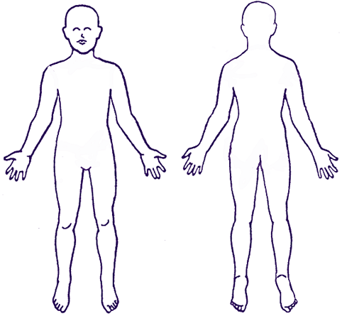
6. Notes to Medic
If the answer to ALL questions in 4 A – I is NO – competitor is free to continue competition

If the answer to ANY question in 4 A – I is YES – competitor is stood down from further competition and must have a registered
medical practitioner complete and sign the clearance to compete form. A paramedic or advanced paramedic cannot complete
7. Notes to Competitor
If the answer to ANY question in 4 A – I is YES, the competitor MUST surrender their competition licence to the Clerk of Course and they are stood down from further competition. A registered medical practitioner must complete and sign the clearance to compete form before competitor can have their licence returned and can resume competition

If the competitor is non-compliant during the medical exam, it must be reported to the Clerk of the Course

8. Summary and Declaration
Competitor is stood down from competition?

Yes / No

*I hereby declare that the above information is true and correct*

Signed: ……………………………………………………………….. Signed: …………………………………………………………
Event medic Injured person (if able)

Name: …………………………………………………………………… Name: ……………………………………………………………

If the answer to the above is YES please ensure that the competitor is in possession of a
Medical Clearance to Compete form

* In all cases the MotorSport New Zealand Medical Assessor Dr Bruce Stewart has the
final determination over a competitor’s fitness to compete *

this form
RESTRICTED CIRCULATION
This report is for the use of MotorSport New Zealand only. Do not distribute to public persons or bodies or the news media without prior written permission from an authorised MotorSport New Zealand Inc. representative.

